

Comprehensive Emergency Management Plan [CEMP]

  - VERSION:
  - APRIL 2024

Approval and Promulgation
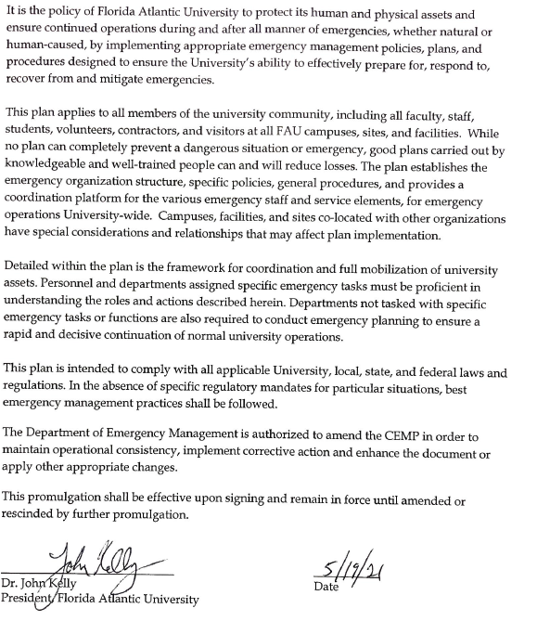

Contents

Approval and Promulgation 2
Contents 3
Record of Changes 6
Overview 7
1. Introduction 7
1.1. Purpose 10
1.2. Planning Methodology 10
1.3. Scope 11
1.4. Plan Organization and Planning Architect 12
1.5. Situation Overview 13
1.6. Planning Assumptions 20
Concept of Operations 24
1. Daily Operations (Non-Emergency) Organizational Structures 24
1.1. Florida State University System 24
1.2. Florida Atlantic University 24
1.3. Department of Emergency Management 25
2. Preparedness Activities 26
2.1. Threat/Hazard Monitoring and Managing Incidents 26
2.2. Mitigation and Prevention 27
2.3. Public Awareness & Education 29
2.4. Training & Exercise 29
3. Emergency Conditions 30
4. Environmentally Sensitive Areas and Wildlife Habitats 31
5. Levels of Incidents/Emergencies 31
6. Plan Activation and Declaration of an Emergency 32
Organization and Assignment of Responsibilities 34
1. Executive Policy Group 35
2. Director of Emergency Management 36
3. Emergency Operations Team 37
3.1. Team Leads 38
3.2. Emergency Support Functions 41
4. Incident Management Team 44
5. Additional Internal Key Individuals or Groups 46
6. External Partners and Entities 47
7. MOUs and MOAs 47
Direction, Control, and Coordination 49
1. University Emergency Operations Center (EOC) 49
1.1. University EOC Activation Levels 50
2. Incident Command Post (ICP) 52
3. Department, Division, Unit Operation Centers 52
4. ICP – EOC Interface and Coordination 52
5. Multijurisdictional Coordination 53
Information Collection, Analysis, and Dissemination 54
1. Information Collection and Analysis 54
1.1. Normal Operating Conditions 54
1.2. Emergency Conditions 54
2. Information Dissemination 55
2.1. Emergency Notification and Alerting 55
2.2. Crisis Communications and Information 55
Communications 56
1. University Units 56
2. FAU’s Police Department 56
3. University Warning Point 56
4. University EOC 57
Administration, Finance, and Logistics 58
1. Administration 58
1.1. Public Records Law 58
1.2. Documentation of Costs (Reimbursable and Non-Reimbursable) 58
1.3. Incident Action Plan (IAP) 59
1.4. After-Action Report (AAR) 61
2. Finance 61
2.1. Procurement 61
2.2. Cost Recovery 62
3. Logistics and Resource Management 62
Education, Training, and Exercises 64
1. Training and Education 64
2. Exercises 64
Plan Development and Maintenance 66
Authorities and References 67
1. Authorities 67
1.1. University 67
1.2. Local 67
1.3. State 67
1.4. Federal 67
2. References 68
Appendix 1 – Declaration, University SOE 69

Record of Changes
Modifications and/or revisions to the Florida Atlantic University – Comprehensive Emergency Management are recorded below.
Change # | Date | Section/  Page(s) | Description | Authorized by
01 | 4/4/24 | Entire Document | Formatting/Branding | Director, EM

Overview

Introduction
Florida Atlantic University (also referred to as FAU or Florida Atlantic) is a public university founded in 1964 in Boca Raton, Florida, with five partner campuses located in the Florida cities of Dania Beach, Davie, Fort Lauderdale, Jupiter, and Fort Pierce at the Harbor Branch Oceanographic Institute. FAU belongs to the 12-campus State University System of Florida. It is accredited by the Southern Association of Colleges and Schools and offers over 180 undergraduate and graduate degree programs within its ten colleges and a professional degree from the College of Medicine. Programs of study cover arts and the sciences, medicine, nursing, accounting, business, education, public administration, social work, architecture, engineering, and computer science. FAU has been classified as a "Research University - High Research Activity" by the Carnegie Foundation for the Advancement of Teaching. The University has changed dramatically since its opening in 1964. More than 30,000 students from all 50 states, every county in Florida, and more than 180 countries attending classes on six campuses spread across 120 miles (193 km) and more than 3,200 faculty and staff. Its annual operating budget is $703 million, generating an annual economic impact for the region that exceeds $6.3 billion.
FAU – Boca Raton Campus
FAU’s main and largest campus is in Boca Raton. It sits on 650 acres with approximately 127 buildings. More than 70 percent of FAU’s 30,000 students take classes at this location, and most of the University’s 180+ degree programs are based here. It houses nearly 4,000 students, athletic and recreational facilities, art galleries, a café/movie theater complex, stadium, ecological preserves, pre-kindergarten through 12th grade educational programs and facilities, and more.
Infrastructure includes University-owned and maintained electrical, water and sewer distribution systems that utilize both above-ground conduits and underground tunnel systems.
The Research Park is home to approximately 20 companies that employ over 1000 people at an average salary of $68,000. The park’s regional economic impact stands at $643 million annually. Over 100 student interns are employed by the research park and Technology Business Incubator (TBI), and collaborative efforts between FAU’s faculty and the research park are increasing.
FAU – Broward Campuses
FAU's three Broward locations support the University's overall mission by providing access to high-quality, complete undergraduate and graduate degree programs to residents of Broward County and the region. Each Broward site—Dania Beach, Davie, and Fort Lauderdale—has a particular focus.
- FAU’s Dania Beach and Sea Tech Research Institute is located between the Atlantic Ocean and the Intracoastal Waterway in Dania Beach. This research center provides expanded opportunities for the Department of Ocean and Mechanical Engineering. Graduate students greatly benefit from conducting research and design projects directly in an ocean environment in acoustics, marine vehicles, marine materials, and nanocomposites, among others. FAU Dania Beach builds on five decades of excellence at FAU, which established the nation's first ocean engineering program in 1965.
- FAU’s Davie location closely partners with Broward College (BC) and other educational institutions and prioritizes offering the complete upper-division portion of high-demand undergraduate degree programs. Graduate programs in education, business, and nursing are available on the Davie campus. The campus is located on BC's central campus. It includes more than 335,000 square feet of classrooms, teaching, research laboratories, the shared-use, 112,000-square-foot FAU/BC library, and other support facilities such as a student Wellness Center and a multiservice Student Union. The campus hosts the innovative Teaching and Leadership Center and is the base of operations for FAU's Everglades research and restoration efforts. In addition, the Davie campus is also home to the Florida Center for Environmental Studies (CES), creating a nexus of scientific endeavors supporting Florida's unique ecosystem.
- FAU’s downtown Fort Lauderdale campus is part of an evolving, dynamic urban community within two towers. The Florida Atlantic University/Broward College Higher Education Complex houses the School of Architecture, College of Business Executive master’s in accounting programs, the Small Business Development Center, The Florida Public Archaeology Network at FAU, Upward Bound, and the College for Design and Social Inquiry's Institute for Design and Construction. The Reubin O'D Askew Tower houses the MetroLAB, an exhibition space for collaborative research and community engagement, amongst other units. This space features the work of students, faculty, and selected guest artists.
FAU Jupiter – John D. MacArthur Campus
This campus is part of a 2,300-acre, mixed-use planned community called Abacoa in Jupiter. This campus is the permanent site for FAU's northern Palm Beach County operations, including the Harriet L. Wilkes Honors College. The campus occupies approximately 45 acres and includes 18 buildings totaling more than 333,000 square feet. Facilities include classroom/office buildings, scientific research buildings, a library, a 500-seat auditorium, residence halls, a dining hall, a museum building, and a central utility plant. Recreational facilities include a soccer field, a swimming pool, and tennis, disc golf, volleyball, and basketball courts. Scripps Florida's 350,000-square-foot, three-building complex is located on the eastern end of the campus. The campus is also home to the Max Planck Florida Institute for Neuroscience, the Max Planck Society's 80th institute worldwide and its first in the United States.
The campus offers courses and programs at the colleges of Arts and Letters, Design and Social Inquiry, Education and Science, and the Harriet L. Wilkes Honors College at Florida Atlantic University. This is a four-year residential college and the first public honors institution in the United States to be built from the ground up.
FAU – Harbor Branch Oceanographic Institute
FAU's Harbor Branch Oceanographic Institute (HBOI), located in northern St. Lucie County, is a state-of-the-art research facility that provides an ideal setting for marine science research and teaching. HBOI is dedicated to exploring the world's oceans, integrating the science and technology of the sea with the needs of humankind. HBOI is involved in research and education in biological, chemical, environmental, and marine sciences; marine biomedical sciences; marine mammal conservation; and aquaculture and ocean engineering.

Figure 1. Map of FAU’s Campuses
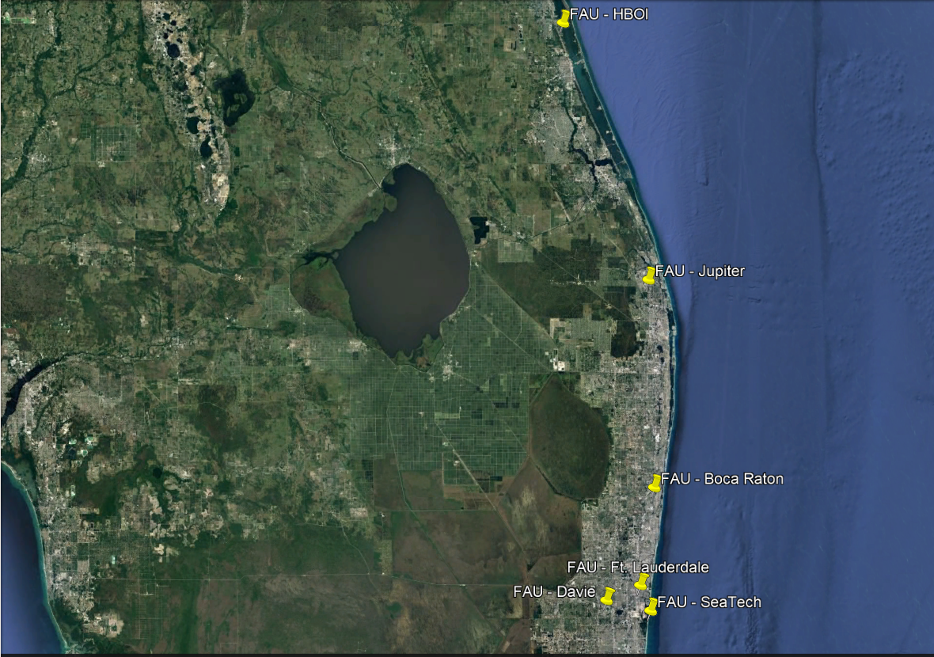

Purpose
The purpose of the Florida Atlantic University Comprehensive Emergency Management Plan (CEMP) is to provide the framework and guidance throughout all five phases of emergency management. The goal is to coordinate university resources to prepare for and prevent potential emergencies whenever possible and deal efficiently with the effects of these events when they do occur; to respond to save and protect lives and protect infrastructure, resources, and the environment; and to promote a means to recover and resume normal operations and continue critical functions and essential services of the University. In all these efforts, the University will continue mitigating as many hazards as possible to promote a resilient, disaster community.

Planning Methodology
The CEMP, as developed under the leadership of the Department of Emergency Management (DEM), guided by input from the Emergency Management Advisory Group (EMAG), and approved by the University President, serves as the pinnacle emergency plan for the institution and supersedes previous versions. The document applies to all agencies, organizations, departments, and personnel that aid or conduct operations in the context of actual or potential emergencies that may affect the University. All other emergency plans that fall under the auspices of the University, including unit-specific plans, should be congruent with the CEMP to facilitate a common approach.
To ensure that the CEMP remains current and responsive to evolving threats and best practices, DEM has established a rigorous maintenance program. This program includes regular review cycles, during which the plan is thoroughly examined and updated to reflect new insights, technologies, and methodologies. Changes are distributed through an established protocol, ensuring that all stakeholders are promptly informed and that the plan remains a living document, adaptable to the changing landscape of emergency management. This proactive approach to plan maintenance ensures its efficacy and relevance, positioning Florida Atlantic to meet emergency management challenges effectively.

Distribution:
An electronic copy of the CEMP is available on DEM’s website, and it is also available to all EOT members in the University’s virtual incident management platform. In addition, DEM retains printed copies.
DEM also distributes copies of Florida Atlantic’s CEMP to include but not limited to:
- Palm Beach County – Emergency Management
- Broward County – Emergency Management
- St. Lucie County – Emergency Management
- Florida Board of Governors
- Broward College
- Palm Beach State College

Scope
The CEMP applies to all major campuses and University sites: Boca Raton Campus, Broward Campuses, John D. McArthur Campus, and Harbor Branch Oceanographic Institute. FAU does share property with partner entities, such as Boca Raton Regional Hospital, Gumbo Limbo, Research Park at FAU, etc. Unit emergency plans are required for these sites, and FAU will work with its partner agencies to provide needed support during emergencies that affect operations that fall under the auspices of FAU at those locations. This plan will also be activated as appropriate for emergencies involving operations occurring under the auspices of the University regionally, nationally, and internationally. This plan provides the framework for all other institutional plans, including campus-specific emergency operations plans and unit emergency plans.
This plan addresses coordinating and managing emergency preparedness, response, recovery and mitigation operations, and various emergency functions by identified divisions, departments, offices, and emergency and incident management teams.

Plan Organization and Planning Architect
Florida Atlantic University has crafted a comprehensive framework for its emergency management plan portfolio, ensuring a structured and systematic approach to handling crises. This framework comprises several key components designed to address various aspects of emergency management effectively:
- Basic Plan: Serves as the cornerstone of the emergency management strategy, outlining the foundational principles, response strategies, and overall coordination mechanisms that guide the university's response to emergencies. The basic plan describes the framework for the university's preparedness, response, recovery, and mitigation activities. It establishes the emergency organizational and administrative structure and overall strategic approach to managing emergencies. It is intended to be flexible and adaptable to address all aspects of an emergency as it evolves and moves through the phases.
- Functional Annexes: These annexes detail specific functions and responsibilities across different departments and units within the university, ensuring a coordinated and functional approach to emergency response activities.
  - Emergency Support Function Annex - Emergency support function annexes supplement the Basic Plan and focus on critical operational functions and the courses of action developed to carry them out. They provide a basic understanding of the units and responsibilities associated with each emergency support function. These functions (Table 1.) are described separately but occur concurrently or consecutively.

- Incident Support Plans: Focused on providing support and resources during specific incidents, these plans outline the logistics, communications, and resources necessary for effective incident management. Incident Support Annexes (ISAs) support the response to emergencies and disasters. They include delving into procedural elements that augment procedures outlined within emergency support function annexes and other plans.
- Incident Specific Annexes: Tailored to address types of emergencies, these annexes offer detailed response strategies and procedures for handling specific incidents, ensuring preparedness for a wide range of potential emergencies. Incident or Action annexes to the CEMP describe the specific or unique courses of action that University units and external partner agencies may take involving particular threats and hazards that affect the University. These annexes are based on unique requirements not standard to other hazards/threats or the addressed in the Emergency Support Function annexes to perform the function adequately in the face of a particular high-priority hazard/threat and on regulatory considerations that may require extensive, detailed planning that is inappropriate for inclusion in the functional annex.
- Standard Operating Guidelines and Procedures: These documents provide clear instructions and protocols for day-to-day operations and emergency responses, ensuring consistent and effective actions across all university levels.
- Program Plans: Encompassing a broader scope, program plans focus on long-term strategies, continuous improvement, and integrating emergency management principles into the university's culture and operations.

Situation Overview
A comprehensive, all-hazards approach to all phases of an emergency is critical because:
- The organizational structure and governance of a higher education institution are unique due to its complex enterprises, such as academic programs, research, business, operations, athletics, transportation, on-campus housing, etcetera.
- Governance is highly varied, complex, and widely dispersed; therefore, decision-making can be slowed.
- Higher educational institutions are amongst the most regulated due to these complex enterprises. Programs must comply with state and federal laws and accrediting body policies.
- The University population and target audience are dynamic and change daily, semester to semester, and year to year.
- FAU operates six campuses that are spread across 120 miles of Florida’s Gold and Treasure coasts,
  - Each location falls within a different municipality.
  - Three locations fall within Broward County, two within Palm Beach County, and one within St. Lucie County.
  - The geographic and topographic footprint and integration with the surrounding communities varies from location to location.
  - Co-location with other educational institutions
  - Most sites are open access with near-round-the-clock activity.
- The University serves distinct populations, including international populations, day-care, and kindergarten through Grade 12.
- Faculty, staff, and students operate under the auspices of the University worldwide.
- The University houses integrated facilities such as the stadium, performing arts center, movie theater, and research entities, including Scripps Florida Research Institute and Max Planck Florida Institute for Neuroscience, etcetera.
This approach includes maintaining a hazard and threat analysis and a capabilities assessment followed by a gap analysis and the development of strategies to overcome shortfalls.

Hazard and Threat Analysis & Risk Consequence Assessment
This is the process by which FAU sets the foundation for the University’s emergency management program. It is comprised of the following elements:
- Hazard or threat identification: identification of potential hazards and threats
- Risk or Vulnerability Assessment: assessment of the level of risk or vulnerability associated with that hazard or threat.
- Consequence assessment: measurement of the effects of the hazard or threat across several mission/functional areas/core capabilities and varying levels of severity.
The hazards or threats are identified and measured across several sets and intensity-grades risk to determine risk exposure:
- Current state: the potential of hazards or threats to be perilous.
- Historical probabilities of occurrence: frequency of occurrence
- Supporting or enhancing environmental conditions: environmental or man-made conditions that may support or enhance the probability of occurrence.
- Mitigating circumstances: environmental conditions or actions that aid in reducing the impact.
Hazards and threats identified within local, state, and federal emergency management agencies will be included and weighted appropriately, as access to support and resources from regional, state, or federal entities may be delayed if the emergency is broad reaching.
Consequence assessments will be performed against each risk exposure to identify the scope of repercussions. These are weighted according to severity and scope and range from:
- Impact on life safety
- Impact on resources: facilities and infrastructure, including Critical Infrastructure and Key Resources (CIKR)
- Impact on essential functions and services, including necessary dependencies.
- Impact on the environment
- Impact on financial affairs/budget/economy
- Impact on regulatory/legal/accreditation requirements and contractual obligations
- Impact on University reputation
Any campus-focused plans will include tailored operations and protocols for specific hazard, vulnerability, and consequence assessments. Respective county analysis and assessment will be incorporated. Sites without specific hazard and vulnerability assessments and risk and consequence assessments will defer to the respective county analysis and assessments and plan appropriately. Co-located sites will collaborate with their partners on emergency management initiatives, including planning, exercises, etcetera, while retaining the right to operate and function according to university policy and direction.
Three categories of variables were assessed to calculate a risk rating score. These categories include the following:
- The probability of the event occurring.
- The impacts on human life, property, and business continuity.
- The current level of Preparedness in terms of the internal and external capabilities of the organization to respond to the hazard. For this exercise, the preparedness measure reflects each Emergency Support Function’s ability to respond to the specific hazard.
The graph and table below illustrate the Top 50 hazards the Emergency Support Function (ESF) teams scored. The bar graph denotes the number of campuses rated that specific hazard as high. As expected, natural hazards dominated the focus of the ESFs due to their frequency and severity. Natural hazards account for the top 19 hazards scored by the ESFs. In the following section, we will take a closer look at the Top 50 hazards in terms of why they are so concerning and what control measures we must limit the university’s exposure to the loss of life, property and/or business continuity.
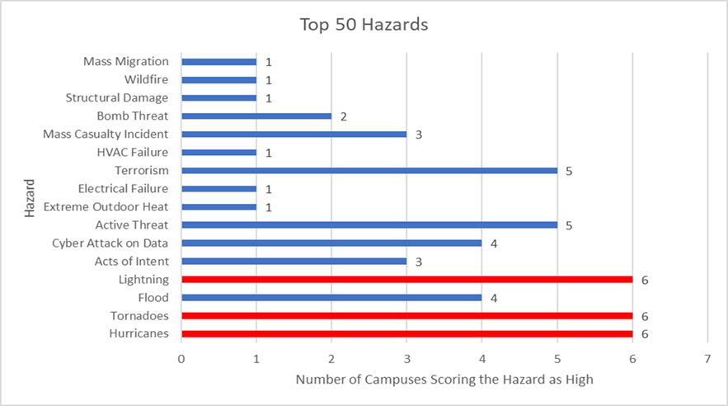
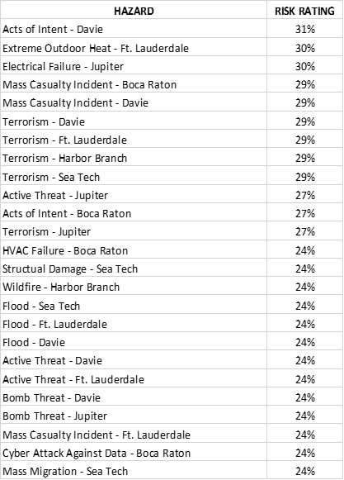
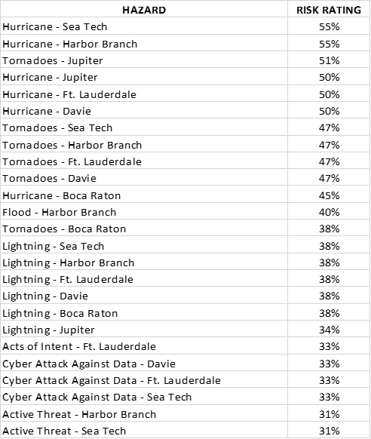

Capability Assessment
Florida Atlantic’s takes a holistic approach to managing emergencies through preparedness and protection, response, recovery, mitigation, and prevention efforts that target our university community of students, faculty, staff, and resources and infrastructure. This is achieved through building, sustaining, and improving individual, unit, campus, and university readiness and resilience.
FAU incorporates the principles described in the National Preparedness Goal and National Planning Frameworks set forth by the Federal Emergency Management Agency (FEMA).
Preparedness is hinged on five mission areas:
- Prevention: avoiding or stopping a threat
- Protection: creating safer, more secure conditions
- Mitigation: lessening the loss of life and property from future disasters
- Response: quickly saving lives, protecting property and the environment, and meeting the basic needs in the aftermath of an emergency
- Recovery: timely restoration of, strengthening, and revitalization of functions – critical and non-critical affected by an emergency
Each mission area consists of core capabilities that the University must execute. These capabilities are met through building, sustaining, and improving individual, unit, campus, and university readiness and resilience through planning, training and exercise, community collaboration, public outreach, and education.
By identifying capability targets that are applicable and appropriate to the University community and sites, given on-going hazard and vulnerability assessments and risk and consequence assessments, the University can direct resources and personnel to affect a comprehensive, all-hazards/threat approach to all phases of an emergency.
Executing these capabilities according to defined targets is described in the functional and hazard-specific annexes of the CEMP. Due to inadequate resources, the University relies on local, county, state, and national entities and institutions of higher education, other external agencies, private partnerships, and mutual aid to assist in executing capabilities.

Table 1. Core Capabilities by Mission Area
Prevention | Protection | Mitigation | Response | Recovery
Planning
Public Information and Warning
Operational Coordination
Safety and Compliance
Procurement and Accounting
Intelligence & Information Sharing |  | Community Resilience | Infrastructure Systems
Screening, Search and Detection |  | Long-term Vulnerability Reduction | Research Operations and Animal Care
Forensics & Attribution | Access Control & Identity Verification | Risk and Disaster Resilience Assessment | Critical Transportation | Economic Recovery
 | Cybersecurity | Threats & Hazard Identification | Environmental Response/Health and Safety | Health and Social Services
 | Physical Protective Measures |  | Facility Management Services | Housing
 | Risk Management |  | Fatality Management Services | Natural and Cultural Resources
 | Supply Chain Integrity and Security |  | Fire Management Suppression | Instructional Continuity
 |  |  | Logistics and Supply Chain Management | Athletics
 |  |  | Mass Care Services
 |  |  | Mass Search and Rescue Operations
 |  |  | On-scene Security, Protection, and Law Enforcement
 |  |  | Operational Communications
 |  |  | Public Health, Healthcare, and Emergency Medical Services
 |  |  | Situational Assessment
*Higher Education specific

Gap Analysis and Development of Strategies to Overcoming Shortfalls
The University determines the areas of improvement by identifying and measuring, as appropriate, anticipated shortfalls. This is done by comparing analyses and assessments to set or determine requirements and/or target capabilities. This drives the development and implementation of emergency management strategies, programs, policies, plans, and procedures to address or eliminate shortfalls.

Planning Assumptions
The following are aspects of the nature of an emergency and/or the effects of scope, complexity, and severity that are treated as true for the purposes of developing the Comprehensive Emergency Management Plan (CEMP).
- Timing and escalation: A disaster may occur with little or no warning and may escalate rapidly, affecting the University’s physical and technological infrastructure, core mission areas, or operations.
- Scope of effects:
  - University:
    - Significant loss of life or severe injury may result depending on the incident location and response time from emergency response agencies.
    - Critical University utilities, communications, and infrastructure systems may be interrupted for extended periods.
    - Disruption of core missions such as academics and research may occur for extended periods.
    - Facilities, grounds, and roadways may be severely damaged, destroyed, or impassable and may persist for extended periods.
  - Surrounding community: Disaster effects may extend beyond university boundaries, and vice versa, and the surrounding environs to any FAU campus or site may experience casualties, property loss, disruption of normal life support systems, and loss of economic, physical, and social infrastructure.
- Plans and preparedness:
  - The succession of events in any emergency is not entirely predictable as disasters differ in character by magnitude, severity, duration, onset, distribution, area affected, frequency, and probability, thus increasing the difficulty of plan development. Therefore, this CEMP and any related plans devised before or during the event will serve primarily as a guide and may require modifications to meet the specific circumstances of the emergency.
  - An emergency or disaster on any of FAU’s campuses is likely to call upon some University resources to perform roles and responsibilities that are different from their normal daily operations. Special planning, training, exercise, and equipment may be necessary to fulfill these non-traditional roles.
  - University colleges, departments, and units will maintain specific emergency plans relevant to their areas and operations and train appropriate personnel regarding plans and procedures. These plans must be considered and aligned with campus and University-level plans.
  - The ability of the surrounding community to effectively respond and recover will significantly impact the University’s recovery; therefore, it is incumbent upon the University to prepare for and carry out response and short-term recovery in conjunction with regional or national partnerships.
- Managing a disaster or significant emergency:
  - Disasters will be managed at the university/campus level. The university will utilize its resources until it is exhausted, or the response and recovery efforts are beyond its capabilities.
  - Florida Atlantic University is a public state university. It is considered by the State of Florida to be a state agency. Through the Department of Education via the Board of Governors, the University is represented on the State Emergency Response Team (SERT) and has direct access to the State Emergency Operations Center (SEOC) and its resources. However, given that the doctrine is that all disasters are local, close coordination with municipal and county entities is essential.
  - Requests for assistance will be submitted to the SEOC with local coordination with the municipality and county entities, other higher education institutions, and through mutual aid agreement channels.
  - The University EOC will be staffed and operated as the situation dictates. The Incident Command System will be employed at the scene, and the Incident Command Post(s) will be staffed and operated as the situation dictates.
  - Resource management, including mission assignment, deployment, and demobilization, will be coordinated through the University EOC when activated during emergencies.
  - Unofficial response groups, the public, and outside resources may hinder response and recovery efforts. Response and recovery services will be coordinated as a university/campus-wide effort.
  - Disasters occurring regionally, nationally, or internationally affect operations, including personnel, under the auspices of the University and will require enhanced or significant coordination with external entities.
- Availability of resources and personnel:
  - As resources are limited at partner campus locations and sites, these will require response and recovery assistance from the main campus and/or unaffected partner campuses.
  - University essential personnel may be affected as well and may not be able to perform critical duties.
  - Access to the University’s sites may be hindered or crippled, thwarting the return of essential personnel to assist with response and recovery efforts.
  - Disaster relief from county, state, or other outside agencies may take up to 72 hours or more to arrive, and there may be competition for resources as an emergency or a disaster may additionally affect residents within proximity to the University’s sites.
- Effective communication:
  - Communication systems are often overwhelmed or disrupted following a major or significant emergency.
  - Effective, timely, and accurate communication and information dissemination is critical.
  - The accurate assessment of received information and its timely dissemination or reporting will facilitate those affected to take appropriate actions and negate the spread of unfounded rumors, panic, and the effects of misinformation.

Concept of Operations
The emergency management organization and structure at Florida Atlantic University applies to all phases of the emergency management cycle (Figure 2.) regarding any actual or potential hazard or threat that is imminent, affecting, or has the potential to affect the University community. The approach is designed to promote and apply best practices and national emergency management standards as appropriate.

Figure 2. Phases of Emergency Management

Daily Operations (Non-Emergency) Organizational Structures

Florida State University System
- Florida’s State University System, which includes the 12 state universities, is overseen by the Florida Board of Governors (BOG) — a 17-member board established to serve as the statewide governing body for the system. BOG members include 14 voting members appointed by the governor, the Florida Commissioner of Education, the Advisory Council of Faculty Senates Chair, and the Florida Student Association president.

Florida Atlantic University
- Florida Atlantic University is governed by a thirteen-member board of trustees, six of whom are appointed by the governor, five by the Board of Governors, in addition to the student body president and the president of the University Faculty Senate. The Florida Senate must confirm the gubernatorial and Board of Governors appointees. The trustees are responsible for cost-effective policy decisions appropriate to the university's mission, implementing and maintaining high-quality education programs, measuring performance, reporting information, and providing input regarding state policy, budgeting, and education standards.
- The President and Executive Leadership Team (ELT), which consists of all Vice Presidents –Financial Affairs, Athletics, Research, Public Affairs, Legal Affairs, Student Affairs, Advancement, Academic Affairs, and Administrative Affairs – affect the policy and advance the mission as set forth by the BOT.
- Executive Leadership Team reporting units manage day-to-day business functions and operationalize the policy and strategic goals and initiatives set by the ELT.

Department of Emergency Management
DEM is made up of four (4) main portfolio areas:
- Planning and Operations: The planning and operations portfolio is crucial in maintaining readiness for the University, blending strategic planning with operational execution to ensure a robust response during emergencies and activations. This dual-focus portfolio area encompasses the dynamic management of the EOC during an activation, where the portfolio area guarantees all stakeholders' presence and optimal functioning within the EOC. This portfolio section is pivotal in planning and coordinating various critical areas. This portfolio is dedicated to planning activities essential for preparedness and resilience. This includes the meticulous preparation and continuous refinement of university-level planning, the Unit Readiness Program, and associated unit-level planning. Through this integrated approach, the planning and operations portfolio ensures that strategic foresight and operational readiness converge, enhancing the EOC’s capability to manage emergencies effectively and sustain critical services during emergencies. In addition, this portfolio is dedicated to fostering partnerships and agreements.
- Preparedness: The preparedness portfolio is critical in building organizational and community resilience through focused community outreach, comprehensive training programs, and realistic emergency exercises. This portfolio leads the charge in developing and executing strategies that prioritize preparedness at all levels, emphasizing the importance of community engagement and collaboration. Central to this portfolio is creating and managing training initiatives and exercises that closely simulate real-life emergencies, ensuring that staff and community members are well-prepared and aware of their roles in emergencies. This portfolio also extends efforts beyond the University by fostering partnerships with local community groups, government agencies, and private entities to enhance the collective response to emergencies.
- Mitigation and Recovery: The mitigation and recovery portfolio is essential in emergency management and is tasked with minimizing future disaster risks and driving effective post-event recovery. This involves reducing potential emergency impacts through resilience and community preparedness initiatives and actively seeking grants and funding to support these efforts. This portfolio includes a strategic balance between implementing mitigation strategies and orchestrating comprehensive recovery plans that ensure business continuity and the continuity of operations.
- Global Travel Safety & Security: The global travel safety and security portfolio plays a critical role in safeguarding the well-being of individuals traveling on behalf of the University. This portfolio is dedicated to developing, implementing, and continuously refining comprehensive safety and security strategies tailored to the unique challenges of international travel.
The structure of DEM is built on an “all-hazards” approach to emergency management. Therefore, there would be no difference in the organization's management structure, no matter what type of emergency or disaster the University may face. The leadership lines of succession are found within multiple planning documents.

Preparedness Activities

Threat/Hazard Monitoring and Managing Incidents
- Units such as law enforcement, facilities and grounds, mental and behavioral health, and environmental health and safety, perform day-to-day monitoring to identify potential hazards and threats, and analyze the impact on the University. Units have the responsibility to report to the University’s 24-hour warning point and their leadership if a situation or incident has the potential to affect or is affecting safety, University resources, the environment or will disrupt the fundamental operating environment, academic, research, business, and other essential services and functions, including necessary dependencies.
- Units will manage incidents that can be managed with typical staffing of the unit or emergency or essential responder entities within the University using existing University resources. Collaboration amongst units may need to occur, but site/campus activity disruption is minimal. This will be done per regulations, laws, statutes, and other governing body policies and guidelines. Mutual aid under these circumstances does not warrant a declaration of a campus/university state of emergency.

Mitigation and Prevention
Hazard mitigation planning is a systematic process for identifying and implementing actions to reduce or eliminate loss of life, property, and function due to natural and man-made hazards. It involves conducting University hazard and threat analysis and risk and consequence assessments, then identifying and implementing strategies to lessen or prevent the hazard or threat from occurring or affecting the University community to the initial extent. Mitigation and prevention planning occurs at various levels within the University:
- All University units have hazard/threat mitigation and prevention in mind to reduce the impact on operations and functions, such as
  - Auxiliary enterprises that provide a substantial amount of financial support and services to the University community.
  - Public safety, facilities and infrastructure, computing, data and communications infrastructure, risk management, environmental health and safety enterprises that provide critical basic operating services.
  - Academic and academic support units whose services range from providing instruction and instructional continuity to faculty interests such as coursework, papers, books, and specimen collections and a wealth of disciplinary knowledge.
  - Student-related services and support units oversee programs tailored to student well-being and academic and career success.
  - Research and sponsored programs that facilitate the University’s research enterprise and substantial research investment.
  - Financial management of university funding is needed to ensure effective and efficient use of university dollars, procure services and goods, and use human capital to effect FAU’s mission.
- Planning bodies exist at many levels within the University that may share an interest or have jurisdiction regarding hazard/threat mitigation, such as
  - Emergency Management Advisory Group
  - University Safety Committee
  - Behavioral Assessment/Intervention Teams (BAT/BIT)
  - Diving and Boating Safety Committee
  - University Faculty Senate
  - Institutional Biosafety Committee
  - Travel Safety and Security Committee
- These bodies (committees, councils, groups, etcetera) share a common focus that is campus or University-wide in scope.
  - StormReady® University: Approximately 98 percent of all presidentially declared disasters are weather-related, leading to around 500 deaths yearly and nearly $15 billion in damage. The National Weather Service’s StormReady® Program began in 1999 to help communities validate their communication capabilities and safety skills to respond to severe weather. StormReady® communities are better prepared through improved planning, education, and awareness programs. While no community is stormproof, being StormReady® does help save lives. FAU became a StormReady® University in 2008 and has maintained the designation. Qualifying criteria include:
    - A 24‐hour warning point and Emergency Operations Center.
    - Redundant methods of receiving severe weather warnings and the ability to alert the University community.
    - A system that monitors local weather conditions.
    - Promoting readiness through community education and awareness.
    - A formal hazardous weather plan includes training severe weather spotters and conducting emergency exercises.
- FAU is a member of the county’s Local Mitigation Strategy Working Group. This group comprises representatives from municipal, county, state, and federal agencies, schools and universities, hospitals, and private industry as a community initiative to develop and execute an ongoing strategy for reducing the community’s vulnerability to identified natural, technological, and human-caused hazards. The strategy provides a rational, managed basis for considering and prioritizing hazard-specific mitigating options and developing and executing sound, cost-effective mitigation projects. This provides a basis for justifying and soliciting local, state, federal, and other funding to support the mitigation initiatives and projects.

Public Awareness & Education
Crises and unexpected events can potentially disrupt University operations with minimal to no forewarning. The University's community needs to be ready to act in emergencies, calamities, or disturbances to facilitate swift reaction and recovery. Emphasizing personal accountability in being prepared is a crucial focus of promotional activities aimed at bolstering the resilience of the University's populace.
The range of experience with readiness, action, recuperation, and prevention among individuals varies widely. As a result, the outreach efforts undertaken by the Department of Emergency Management (DEM) are designed to build on these varied backgrounds, correct misunderstandings, or broaden the scope of what people already know. The aim here is to elevate the preparedness of everyone associated with the University to new heights. Recognizing the evolving nature of how the University community engages with and digests information, DEM has moved away from relying solely on one-way communication to disseminate vital preparedness messages.
DEM integrates interactive online platforms, webinars, and other outreach channels into its educational initiatives to reach a wider audience and cater to diverse learning preferences. This innovative, digital, and widespread expansion allows for a broader, more engaging dialogue around safety and preparedness, enabling instant access to resources and information across the University's community.

Training & Exercise
The University's training and exercise program is designed to meet the comprehensive training and exercise needs of DEM, the Emergency Operations Team (EOT), University Personnel, and internal and external stakeholders. Engagement in the University's training and exercise initiatives varies among stakeholders, depending on the topics being explored.
Selecting the right type of exercise for stakeholders is crucial to achieving successful outcomes in skill enhancement and the effective management of and recovery from emergencies. The Emergency Management Coordinator (Preparedness) is pivotal in ensuring that all necessary and requested training sessions are organized efficiently and that exercises comply with the standards set by the Homeland Security Exercise and Evaluation Program (HSEEP). The courses offered by DEM are designed to comply with the National Incident Management System (NIMS) and improve the competencies of University personnel.
Just-in-time learning/training is a critical component of our approach, aimed at providing essential information, knowledge, or skills precisely when the learner requires it. This methodology is particularly beneficial for emergency activation roles, equipping individuals with the necessary skills when needed. To achieve this, the University utilizes various delivery methods, including online, in-person, and on-the-job training, to accommodate the diverse needs of new and returning employees and volunteers. This blended approach ensures the maximization of skill sets critical for effective emergency response and management within the University context.

Emergency Conditions
- On-scene management of the incident will adhere to National Incident Management System principles and guidelines.
- Once notified of an actual or potential emergency, the University President or designee will utilize the CEMP and activate emergency response and emergency support functions as outlined in the Plan. This will also include activation of the University’s Emergency Operations Center and other actions as appropriate.
- Upon activation of the Emergency Operations Center (EOC), emergency operations across organizational units of the University will be coordinated through the EOC to fulfill the functions and roles as described in the plan or as appropriate. The University Emergency Operations Center will assist in or dictate the activation of partner campus emergency operations and sites.
- The Emergency Operations Center (EOC) will be staffed according to the needs to manage an emergency throughout its lifecycle effectively. This will include representation by establishing communication channels with external agencies and partners.
- Requests regarding the University’s unmet needs from external entities will follow established protocols.
- The CEMP is designed to guide emergency operations and is a university-wide decision-making tool.

Environmentally Sensitive Areas and Wildlife Habitats
Some of FAU’s campuses contain environmentally sensitive areas and wildlife habitats. Efforts will be made to conduct emergency operations away from, and caution and care will be exercised when conducting operations adjacent to these areas. If this is not possible, due to the nature, complexity, scope, or magnitude of impacts of the emergency or incident, the University will involve the appropriate regulatory entities, as necessary.

Levels of Incidents/Emergencies
- Monitoring/Routine Incident: These involve the day-to-day monitoring by university units (law enforcement, facilities and grounds, mental and behavioral health, environmental health and safety, weather, etc.), identifying potential hazards and threats, and analyzing the impact on the University. It can also be an incident managed by typical staffing of emergency or essential responder entities within the University using existing resources. Collaboration amongst units may need to occur, but site/campus activity disruption is minimal. An Incident Command Post may be activated, but not all sections are needed. The Emergency Management Team (EMT) is not activated or placed on standby. The Emergency Operations Center is not activated beyond the Department of Emergency Management staff or other appropriate staff for enhanced monitoring involving incidents that can potentially escalate. Continuity of operations/recovery operations are typically not activated. Operationally, this definition translates into a Level 4 or 3 activation of the Emergency Operations Center (See Section IV. Direction, Control, and Coordination; A. University Emergency Operations Center)
- Minor Incident: These incidents have a notable deployment of university resources. These do not demand a full response from the Emergency Management Team; only select functions are activated depending on the nature and severity of the event. Continuity of operations/recovery operations are relegated to one or more FAU sites but not University-wide. Some functions are disrupted for 12 hours to a few days. Operationally, this definition translates into a Level 3 or 2 activation of the Emergency Operations Center (See Section IV. Direction, Control, and Coordination; A. University Emergency Operations Center)
- Major Incident: These incidents lead to significant deployment of university resources. Type 1 and 2 incidents overwhelm most or all University resources, and local, state and/or federal assistance is required. These are typically 24-hour operations involving the recall of most essential personnel and emergency responders moving to 12-hour shifts. All emergency support functions of the University’s Emergency Management Team are activated, and the Emergency Operations Center is fully operational. There may be more than one on-scene management site or Incident Command Post. Continuity of operations and recovery may extend into weeks. Most, if not many, functions impacted. Operationally, this definition translates into a Level 2 or 1 activation of the Emergency Operations Center (See Section IV. Direction, Control, and Coordination; A. University Emergency Operations Center)

Plan Activation and Declaration of an Emergency
The decision and authority to declare a university or Campus State of Emergency rests solely with the University President or designee. The Executive Policy Group (EPG) of the Emergency Management Team (EMT) guides the President regarding the need for the declaration. During a state of emergency, normal university/campus operations are suspended, and measures necessary to meet the emergency and safeguard persons and property will be enacted to the greatest possible extent.
The mission essential functions and/or priorities and objectives of Florida Atlantic University when facing an emergency are as follows:
- Protect the health and safety of the university community affected by the emergency,
- Stabilize or resolve the incident(s), including providing basic care services,
- Protect the facilities, infrastructure, and the environment,
- Minimize disruption to maintain or restore operations, including the basic operating environment, academic, research, business and financial, and other essential services and functions, including necessary dependencies,
- Restore or resume normal University operations and activities promptly.
For any Florida Gubernatorial or United States Presidential declaration of an emergency that affects or has the potential to affect any University site, the University will initiate appropriate measures to meet the emergency and, to the extent possible, enact measures to safeguard persons and property, under the declaration, if a university emergency declaration has not been executed. Without a university emergency declaration, a Florida Gubernatorial or United States Presidential declaration of an emergency for the university’s service area may be used to enable cascading drivers.

Organization and Assignment of Responsibilities
The organizational structure consists of several components that affect emergency management operations during all emergencies. This consists of the emergency's on-scene and off-scene/no-scene management (Table 2). This structure is implemented University-wide:
Table 2. On-scene and Off-scene Emergency Management Components
 | On-scene  Incident Command | Off-scene/No-scene – Emergency Operations Center | Off-scene/No-scene – Policy Group
Description | • A local or tactical incident management organization established to enable timely, effective, and coordinated operations by integrating a combination of facilities, equipment, personnel, services, procedures, and communications to achieve incident objectives  • Organized by Incident Command System | • A central location for inter-unit, campus, and interagency coordination and decision making to support incident management  • Organized by Emergency Support Functions | • Senior University officials for support of the incident and emergency through their collective resources, strategy development and policymaking
Personnel | • Command & support staff (if necessary) | • Director, support staff, Teams, and Groups | • President and senior administration officials
Typical Functions | • Manages the incident(s)  • Provides information to the decision-makers regarding all important matters related to the incident | • Provides support & resources to manage incident(s) according to functional areas. | • Allocate resources in support of all functions  • Develop strategies and contingency plans
EM Phase | Response, early/initial Recovery | All phases | All phases
Other | • Incident commander is responsible for overall management of the incident in either a single or unified command structure | • Link between ICP and EPG | • May establish the priorities for resources among incidents  • Harmonize policies, and provide strategic guidance and direction to support emergency management activities

Executive Policy Group
This group consists of the President or designee and selected senior administrative officials of the University as designated by the President or designee as the emergency dictates. This policy group provides direction, policy, and strategy for emergency operations for the University. It is comprised of the leaders of the University’s critical emergency operations units:
- President
- Vice President – Academic Affairs and Provost
- Vice President – Administrative Affairs and Chief Administrative Officer
- Vice President – Financial Affairs and Chief Financial Officer
- Vice President – Student Affairs and Enrollment Management
- Vice President – Legal Affairs
- Vice President – Research
- Vice President – Public Affairs
- Additional vice presidents, deans, or other unit leaders can be added at the president's discretion on a temporary, ad-hoc basis, depending on the nature of the emergency, its severity, and its consequences.
Tasks performed by the Policy Group are as follows:
- Upon notification of an emergency or threat that requires strategic, financial, operational, or policy decisions, the Chief Administrative Officer will initiate a meeting of the EPG.
- Once convened, the EPG will guide to mitigate or address the immediate impacts on the safety and provision of basic care, operations (research, academics, business, facilities, grounds, infrastructure, environment), legal status, or finances brought about by the actual or potential incident size/scope, intensity, immediacy, and duration.
- The EPG may call upon subject matter experts or support personnel to offer consultation to aid in decision-making.
- The EPG will establish and maintain regular, ongoing communications with the University’s Board of Trustees (BOT), Board of Governors (BOG), Governor, and other officials as appropriate.
- The EPG will establish and maintain communications and contact with the EOC Director for situation updates and to disseminate policy and decisions to be acted upon/effected.
- The EPG will reconvene as appropriate to develop strategy and policy to mitigate or address forecasted or future impacts to safety and provision or facilitation of medical and behavioral health, continuity of operations (research, academics, business, facilities, grounds and infrastructure, environment), legal status, and recovery efforts.

Director of Emergency Management
The Director of Emergency Management serves as the principal manager for emergency operations. Board of Governors Regulation 3.001 “Campus Emergency Management” directs each University to establish and appoint an individual to carry out the provisions of emergency management programming. The Director, or in the Director’s absence, the Assistant Director of Emergency Management, is designated as the emergency manager for the University. In this capacity, the Director is directly responsible for:
- Organization, administration, and operation of the Department of Emergency Management, the Emergency Operations Center, and other related operational facilities.
- Coordinate activities, services, and programs for emergency planning, response, recovery, mitigation, and continuity of activities throughout the university.
- Maintaining liaison with state, federal, and other local emergency management agencies.
- Development and maintenance of operational planning for emergency response.
- Ascertaining the requirement of the University to implement emergency response operations, including reviewing and approving university emergency operations plans and procedures.
- Promulgating a timeline for units to submit emergency operations plans for review and approval by the Department of Emergency Management.
- Instituting training programs and public information programs.
- Taking all necessary preparatory steps, including the partial or full emergency mobilization of units in advance.
- Taking measures to carry into effect any request from Units, municipalities, counties, the State Division of Emergency Management, or federal agencies for appropriate emergency management activity.

Emergency Operations Team
This team provides recommendations to the Executive Policy Group (EPG) and “operationalizes” the policy and strategy set forth by the EPG through all phases of an emergency. The EOT is activated based on the nature of the emergency, its severity, and its complexity. It consists of emergency support functions led by primary or lead units with additional resources, proficiencies, competencies, and information provided by supporting units. Members are subject matter experts for the areas they represent and have authority or delegated authority to facilitate and coordinate tasks to effect emergency operations.
Tasks performed by the EOT are as follows:
- Upon notification of an emergency or threat that requires notable or significant deployment of university resources, the EOC Director will convene the EOT as appropriate. Depending on the severity and complexity of the emergency, EOT members will be asked to report or be placed on standby to report as the emergency evolves or progresses.
- Depending on the emergency, the EOT will initially be convened in a physical location or virtually. This may change throughout the emergency.
- EOT representatives will assist in set-up, reorganizing, and demobilizing the Emergency Operations Center (EOC) as needed.
- EOT representatives liaise with the departmental, divisional, or small-unit operations centers and liaise with external agencies and partners as appropriate.
- The EOT continuously gathers information from and disseminates information and tasks, as appropriate, to the Incident Management Team(s) (IMT) and the departmental/divisional/unit emergency operations group(s), regarding the actual or potential incident size/scope, intensity, immediacy and duration, impacts to safety and provision of basic care, operations (research, academics, business, facilities, grounds and infrastructure, environment), legal status or finances, impact on ongoing or planned events, and additional resources or technical assistance needed to respond and recover. This common operating picture or situational awareness is then analyzed, presented to the Executive Policy Group (EPG) for policy and decision-making, and utilized to forecast or predict future impacts.
- This team determines which segments of the University’s target audience need to be alerted or provided with crisis communications regarding the emergency and will establish and maintain these communications throughout the life cycle of the emergency as appropriate.
- EOT members should be prepared to fulfill their roles and prepare their places of work or residences in case of an emergency. They must consider any limitations or challenges, such as geographical, physical, and organizational, and maintain and have ready Go-To-Kits, equipment, plans, and other necessities to effectively liaise and serve.
- A sub-group of the EOT is the Campus Emergency Coordination Center (CECC) representatives. These individuals are located on FAU’s partner campuses and aid EOT members in coordinating partner campus-specific emergency operations. They report to the Coordination & Planning emergency support function and perform the following tasks:
  - Set up, ready, and break down the partner campuses’ Emergency Coordination Center locations as directed by the Coordination & Planning emergency support function.
  - As appropriate, assist with partner campus-specific coordination efforts before, during, and after an emergency in support of emergency operations and the EOT.
  - Provide situation status updates regarding partner campus-specific emergency operations to the Coordination & Planning emergency support function, as required.

Team Leads
As required, the CEMP assigns a team lead responsible for increased coordination of Emergency Support Functions (ESFs) by the team. A team lead is designated because they either have a statutory responsibility to perform such a function, or through its programmatic or regulatory responsibilities, the unit may have developed the necessary expertise to lead the group/functions assigned. In some cases, a portion of the unit’s mission may be like the mission of the group/function; therefore, the skills required to lead and organize the team in response to a disaster can be immediately translated from the daily functioning of the group.
A team lead is an individual imparted with significant authority, roles, resources, or capabilities for their assigned group/function. The team lead has ongoing responsibilities throughout incident management's preparedness, response, recovery, and mitigation phases. The team lead synchronizes all ESFs within their group to ensure that missions are accomplished, and resources are maximized. Team leads report to the Emergency Operations Center Director. While the operational responsibilities of each team lead are outlined in supporting annexes, some universal responsibilities of a team lead include:
- Coordination before, during, and after an incident, including pre-incident planning and coordination among their assigned team.
- Maintaining ongoing contact with assigned ESFs.
- Conducting periodic meetings, conference calls, and collaboration sessions to ensure operational readiness.
- Ensuring each assigned ESF is staffed upon activation of the EOC, and continual coverage based on the activation level.
Team leads are designated by the Director of Emergency Management and are identified in the FAU CEMP -ESF Annex. If circumstances warrant a permanent change in a designation to a team lead (beyond a singular incident), the designated team lead shall send a memorandum to the Director of Emergency Management, with a copy to the new ESF or unit, describing the reason for the change. Upon approval by the Director of Emergency Management, the modification will be reflected in the annex, and the new team lead shall coordinate any new authorities, responsibilities, and procedures.

Figure 3. Emergency Operations Team Structure by Emergency Support Function
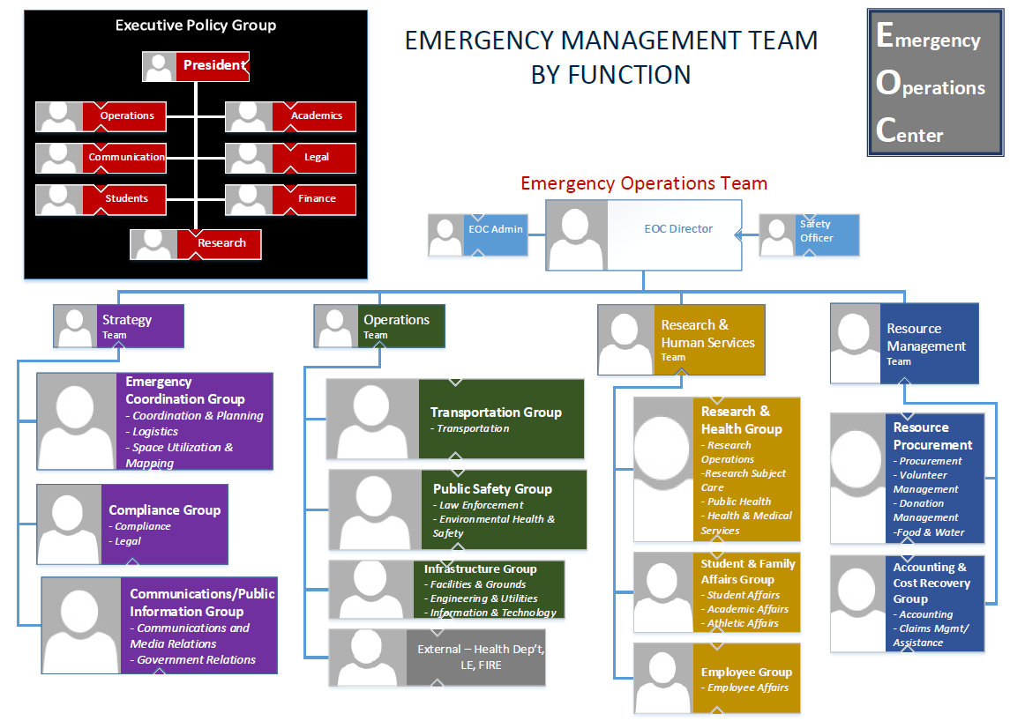

Emergency Support Functions
Emergency support functions are derived from the capabilities that must be performed, met, or attained to manage emergencies effectively. Representatives from lead units comprise the EOT and serve within the University EOC. They lead the coordination of tasks associated with the emergency support function that they represent to ensure capabilities are met. This includes coordinating with external agencies and partners for additional support, resources, capabilities, guidance, and direction as appropriate, agreed upon, or necessary. This structure is implemented university-wide for standardization in managing emergencies. The emergency support functions and respective lead and supporting units are illustrated in the table below.
Table 3. Emergency Support Functions and Corresponding Internal/External Units
 | Emergency Support Function | Lead Unit | Supporting Units | External Agency/Partners
Emergency Coordination Group | Coordination & Planning | Emergency Management | All | Local, County, State and DEM/EOC, Partner Institutions
Emergency Coordination Group | Logistics | Emergency Management | All | Local, County, State and DEM/EOC, Partner Institutions
Emergency Coordination Group | Space Utilization & Mapping | Space Utilization | All | N/A
Compliance Group | Compliance | University Compliance Officer | All | Regulatory Agencies, Response Agencies and Service Providers, BOG
Compliance Group | Legal | General Counsel | All | Regulatory Agencies, Response Agencies and Service Providers, BOG
Communications/ Public Information Group | Crisis Communications and Media Relations | Public Affairs | All | Media
Communications/ Public Information Group | Government Relations | Governmental Affairs | All | BOG, state and local representatives, Governor's Office
Public Safety Group | Law Enforcement | FAU Police Department | All, University Warning Point | Local, State and Federal Emergency Responders, and Law enforcement, Fusion Center, Joint Task Force, other local, state, and federal Public Safety Agencies, Local, state, and federal Victims Assist. Programs, and Non-Governmental Victim’s Services Organizations
Public Safety Group | Environmental Health & Safety | Environmental Health and Safety | Facilities Management, FAU Police Department, Research | Fire Rescue, Dept. of Environmental Protection, Florida Wildlife Conservation, Bureau of Radiation Control, and other Local, State and Federal entities
Infrastructure Group | Facilities & Grounds | Facilities Management - Physical Plant | All | Municipal Public Works, Contractual Partners, other Local, State and Federal entities
Infrastructure Group | Engineering & Utilities | Facilities Management - Engineering & Utilities | All | Municipal Public Works, Florida Power and Lights, Service Providers, other Local, State and Federal entities
Infrastructure Group | Information & Technology | Office of Information Technology | Facilities Management, others as appropriate | Telecommunications and Data Infrastructure Entities and Service Providers
Transportation Group | Transportation | Parking and Transportation | All | Transit Authority, Other Local, State, and Federal entities
Research Group | Research Operations | Research – DOR Operations | Research Operations, Veterinary Services, EH&S, Facilities Management | Regulatory and Accreditation Bodies
Research Group | Research Subject Care | Research 0 Comparative Medicine | EH&S, Facilities Management | Regulatory and Accreditation Bodies
Health Group | Health and Medical Services | Student Health Services | EH&S, Owls Care, College of Medicine, College of Nursing, Public Safety, Student Affairs, Human Resources, | Community Health Partners, Emergency Medical Services, Local and State Health Department, Centers for Disease Control, National Institutes of Health, World Health Organization, Service Providers
Health Group | Public Health | Environmental Health & Safety – Public Health | FAI Police Department, Human Resources, Student Affairs | Community Health Partners, Emergency Medical Services, Local and State Health Department, Centers for Disease Control, National Institutes of Health, World Health Organization, Service Providers
Student & Family Affairs Group | Student & Family Affairs | Student Affairs | FAU Police Department, Business Services, Academic Affairs, Legal Affairs | Service Providers
Student & Family Affairs Group | Academics | Academic Affairs | All Support Units, A.D. Henderson, Karen Slattery Daycare Center | Department of Education, Palm Beach County School District, SACSCOC
Student & Family Affairs Group | Athletic Affairs | Athletics | Student Affairs, Other Support Units as Appropriate | NCAA
Employee Group | Employee Affairs | Human Resources | All | Service Providers, Employee Assistance Program, Department of Labor, other Federal and State Agencies
Accounting & Cost Recovery Group | Accounting | Controller | All | Division of Financial Services, Board of Governors
Accounting & Cost Recovery Group | Cost Recovery | Environmental Health & Safety - Risk | All | Insurance Providers, Federal Emergency Management Agency, Division of Risk Management
Resource Procurement Group | Procurement | Purchasing | All | Division of Financial Services, Board of Governors, Service Providers
Resource Procurement Group | Volunteer Coordination | Student Affairs | All | American Red Cross, Volunteer Florida, other Local and State Programs
Resource Procurement Group | Donation Management | Institutional Advancement | All | As appropriate
Resource Procurement Group | Food & Water | Business Services | Procurement, Emergency Accounting, Donation Management | Service Providers, Private Industry

Incident Management Team
This team contains, stabilizes, or resolves the on-scene incident(s) and manages the field operations associated with that process. The Incident Management Team (IMT) carries out direct, tactical operations using pre-established procedures to manage the incident from the time the incident occurs until the requirement for management and operations is no longer needed. It is an organized group comprising appropriate internal and external emergency responders, essential responders (staff, students, service providers, faculty, etc.), and other support personnel assigned to manage an incident. It is organized according to the Incident Command System (ICS) that sets forth a standardized structure (Figure 4.) for managing hierarchies to control communications, safety, facilities, equipment, personnel, and funding that is scalable and flexible to address incident complexity and severity. Multiple incidents require multiple teams.
Given the complex enterprises and governance structure that comprises higher education and, by extension, FAU, the IMT is organized by University campus or site. However, incidents may overwhelm an FAU campus’ capabilities and resources. Due to the predominantly centralized organizational structure of the University, capabilities, and resources can be easily shared amongst any of FAU’s campuses or sites.
Tasks performed by the IMT(s) are as follows:
- Upon discovering or confirming an emergency or threat, assume command and management of the incident. The most qualified person(s) will be appointed as the incident commander(s) for a single or unified command to provide overall leadership for incident management and emergency response activities.
- This team will continuously assess the incident's nature, severity, and complexity and activate appropriate personnel to manage it.
- Single or unified command will maintain a span of control and a clearly defined chain of command, unity of command and transfer of command throughout the incident.
- The IMT will establish and maintain contact with the EOC if activated, or the Department of Emergency Management and continuously provide information using standard protocols regarding incident specifics, such as incident size/scope, intensity, immediacy and duration, impacts to safety and provision of basic care, operations (research, academics, business, facilities, grounds, and infrastructure, environment), legal ramifications, impact on ongoing or planned events, and additional resources or technical assistance needed to manage the incident.
- This team will establish objectives, set priorities, and formulate and execute tactical and action plans to mitigate, stabilize, or resolve the incident per policy and direction set by the Executive Policy Group (EPG) and support and resources provided by the Emergency Operations Center (EOC).
- This team will utilize and maintain operational locations and support facilities and manage associated resources (personnel, equipment, supplies) supporting incident management and emergency response activities.
- This team will facilitate communications using an integrated, interoperable approach and coordinate the information and intelligence gathering, sharing, and managing process throughout the incident.
- IMT personnel should be prepared to fulfill their roles and prepare their places of work or residences per the incident(s) at hand. They must consider any limitations or challenges, such as geographical, physical, or organizational, and maintain and have ready resources, equipment, plans, and other necessities to effectively stabilize, mitigate or resolve the incident(s).
Figure 4. Incident Command Structure
COMMAND
Single or Unified
Operations
Logistics
Planning
Finance
COMMAND Staff
Safety
Officer
Agency Liaison
Public Information Officer
Responsible for getting the objective accomplished.
Restores services, repairs damage, life safety, etc.
Evaluates status of incident.
Forecasts course of incident
Prepares plans of action
Provides facilities, supplies, and support (i.e. communication, transportation, medical, food service, etc.)
Responsible for financial records associated with the incident.

Additional Internal Key Individuals or Groups
As outlined in University Policy 1.14 (Emergency Management), some additional key individuals and groups contribute to the holistic management of emergencies, such as:
- The University President or designee exercises final authority concerning decisions involving suspending normal operations for any FAU campus or site and holds the authority to declare the University State of Emergency. The order of succession should the President be unavailable is as follows:
  - Co-Presidential Team
    - Academics: Provost and Chief Academic Officer
    - All Other Functions: Vice President of Administrative Affairs and Chief Administrative Officer
- Emergency Management Advisory Group: Assists in developing University and campus-level emergency management programmatic elements.
- Department of Emergency Management: Facilitates administrative oversight for the University’s emergency management program.
- Organizational Units: Develop and maintain unit emergency plans that are consistent with campus and University plans, ensure that their staff are knowledgeable regarding unit plans, identify and designate staff who are critical to performing essential functions for their unit, the University as a whole, and enact unit emergency plans when appropriate or necessary.
- Essential Personnel: Perform essential functions for their units and the University. The Employee Affairs ESF oversees this program.

External Partners and Entities
FAU maintains partnerships and coordination with several external entities to effect preparedness, response, recovery, mitigation efforts, and operations. These partners will be called upon to assist during a significant emergency or dangerous situation. This is done through the Emergency Support Functions. They range from local resources, such as municipal law enforcement, fire rescue, and public works and utilities, to county resources, such as county emergency management departments, health departments, law enforcement, and transit systems, to state resources, such as the Florida Division of Emergency Management, the Department of Environmental Protection, partner institutions of the State University System, to federal resources such as Federal Bureau of Investigations, the Centers for Disease Control and Prevention, National Weather Service and the National Hurricane Center.
Private partnerships, mutual aid, and service providers such as vendors and contractors also serve during emergency operations as needed.

MOUs and MOAs
The University is part of agreements that enable it to collaborate with various external agencies and other institutions. The National Intercollegiate Mutual Aid Agreement (NIMAA) is an example of such agreements, promoting joint efforts among member institutions in disaster-related activities, including exercises, testing, and emergency support. In addition, the University is a signatory to various agreements within the State University System (SUS), such as sharing counseling services and resources.
If the University finds itself overwhelmed during an emergency, it can request help through any of the county's Emergency Operations Center (EOC). In more severe emergencies, where the State Emergency Operations Center (SEOC) raises its response level, the University has the option to seek aid via the Board of Governors’ representative on the State Emergency Response Team (SERT). Moreover, the University has committed to the Statewide Mutual Aid Agreement (SMAA), which enables it to request assistance formally or informally during major emergencies or disasters.

Direction, Control, and Coordination
FAU assumes a multi-pronged approach that must span all phases to achieve a holistic means to manage emergencies. The University does this using the Incident Command System (ICS) for on-scene incident management, Departmental/Divisional/Unit Operations Centers (D/U OC), and Multi-Agency Coordination Centers (MACS), namely, the University’s Emergency Operations Center (EOC), and Campus Emergency Coordination Center (ECC) (Figure 5).
Figure 5. Emergency Coordination
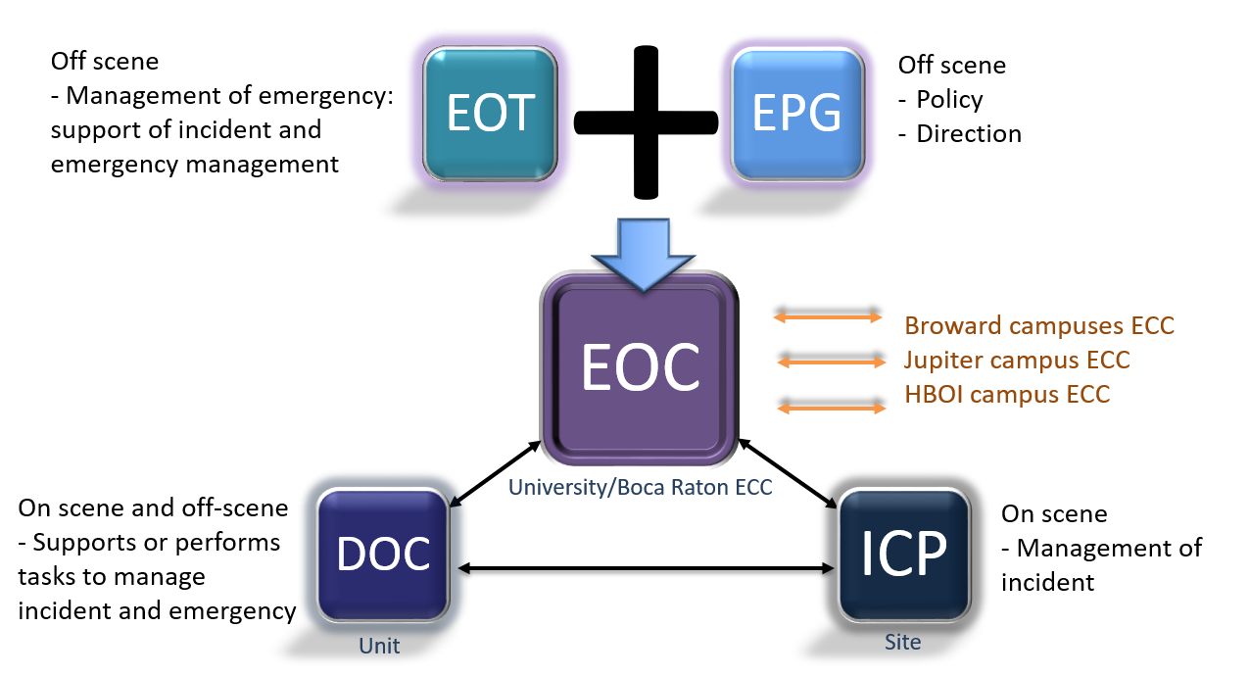

University Emergency Operations Center (EOC)
The University Emergency Operations Center (EOC) is a physical facility or virtual space from which centralized and coordinated multi-unit support and resources for tactical incident management occurs. Through the Emergency Support Functions, University EOC staff share, collect, and disseminate information; support resource needs and requests, including allocation and tracking; and coordinate plans and determine the current and future needs to stabilize and resolve the emergency. Additionally, personnel support public information, crisis communications, and emergency notification; liaise with partners as needed; and support the policy and legal needs of the on-scene and off-scene components of the emergency.
The EOC Director will facilitate and coordinate the escalation/de-escalation of activation levels of the EOC upon direction from the President or designee.

University EOC Activation Levels
As the emergency grows in scope and complexity, the EOC activity grows to meet the needs for support and coordination. The University EOC will escalate activation levels for an emergency on any campus depending on the nature, severity, and complexity and the ability of campus units to contain, stabilize, and resolve the incident and manage the emergency. University EOC activation levels are intended to align with Broward, Palm Beach, and St. Lucie Counties’ Department of Emergency Management and the Florida Division of Emergency Management’s EOC Activation Levels as appropriate. Table 5. EOC Activation Levels provide a reference framework however, actual staffing is at the discretion of the Emergency Operations Center Director.
Table 4. EOC Activation Levels
Activation Level |  | Description
4 | Normal Operations/ Monitoring | - Normal day-to-day monitoring by university units (law enforcement, facilities and grounds, mental and behavioral health, environmental health and safety, weather, etcetera.) and university warning point of world, national, regional, and local news; regional weather forecasts and space forecasts to identify potential hazards and threats and analyzing impact to the University.  - Incidents that can be managed by normal staffing of emergency or essential responder entities within the University using existing University resources. Collaboration amongst units may need to occur but disruption to site/campus activity is minimal.  - EOC not staffed. Campus Emergency Coordination Center(s) not staffed.
3 | Enhanced Steady State/ Monitoring | - Incidents that have the potential for escalation or special events prompt this level of activation. University Warning Point, Department of Emergency Management and/or other University unit personnel are actively monitoring and assessing the incident/event.  - These can generally be resolved in a brief period and with a small number of resources.  - Notifications are made to appropriate University units and appropriate support organizations and/or service providers, that may be required to take appropriate action as part of their everyday responsibilities.  - EOC may be staffed with EOC Director, EOC Admin. Campus Emergency Coordination Centers (CECCs) may be staffed with emergency administrative personnel. If a CECC is staffed, it is required to establish and maintain communications with the University EOC.
2 | Partial | - Potential or actual incidents that require notable to significant deployment of university resources. These do not demand a complete response from the Emergency Management Team (EMT): The Strategy Team is fully activated for emergency coordination, safety and compliance, and communications/public information functions, and only select other Emergency Support Functions are activated as appropriate. EMT representatives who are not asked to report for duty are placed on standby.  - Campus Emergency Coordination Center(s) (CECC) is activated to manage the incident and/or provide support and resources to other University campuses or sites.  - The Executive Policy Group convened initial meetings for immediate or impending strategic, financial, operational, or policy decisions based on present or forecasted conditions.  - The EOC may be operational 24 hours per day.
1 | Full | - Imminent or actual incidents requiring significant deployment of university resources. Most or all University resources are overwhelmed and local, state and/or federal assistance is required.  - Typically, 24-hour operations involve recalling most essential personnel and emergency responders moving to 12-hour shifts. All emergency support functions of the University’s Emergency Management Team and EPG are activated, and the EOC is fully operational and expected to be activated for an extended period.  - Most or all Campus Emergency Coordination Center(s) (CECC) are activated to manage the incident and provide support and resources to other University campuses or sites.

Incident Command Post (ICP)
When on-scene management is needed to stabilize and resolve an incident at any FAU site, an Incident Command Post will be established using the principles of the Incident Command System (ICS). This ICP will house the Incident Management Team (IMT), described earlier in this plan. The ICP will be established at or near the scene of an incident as permitted to ensure the safety of the IMT. It will be clearly marked to all representatives of the IMT. The activities of the post will be coordinated or directed by an Incident Commander (IC) or Unified Command (UC). The IC/UC comprises the most qualified individual(s) to oversee the management of the incident. The ICP, through the IC/UC, will establish and maintain communications with the University EOC using standards protocols and procedures until the incident is stabilized and resolved and the IMT and incident operations are demobilized. Multiple incidents on the same site/campus or multiple sites/campus will require multiple ICPs.

Department, Division, Unit Operation Centers
Units within the University affect or support preparedness, response, recovery, mitigation, and prevention activities. Each unit is responsible for its unit personnel's safety and the protection of its resources and facilities. They are required to maintain emergency plans that address preparedness, response, and recovery, including operations continuity. The Emergency Operations Team (EOT) representatives liaise with their respective unit leadership to provide resources and support to manage emergencies. Critical and key unit personnel comprise the Incident Management Teams (IMTs) and Emergency Management Team (EMT), staff the Campus Emergency Coordination Centers (CECCs) and fulfill the core capabilities throughout the lifecycle of an emergency.

ICP – EOC Interface and Coordination
Once an ICP or ICP is established for on-scene incident management, the Incident Commander will establish and maintain communications with the Emergency Support Function – Law Enforcement within the Emergency Operations Center. Vice versa, law enforcement will establish and maintain communications with the Incident Command Post(s) for the Emergency Support Function. For an incident occurring on a partner campus or incidents occurring concurrently on multiple campuses, the Emergency Support Function – Law Enforcement for the Emergency Operations Center will establish and maintain communications with the respective ICP(s). Additionally, for concurrent incidents on multiple partner campuses, the Emergency Support Function - Coordination & Planning within the University EOC will establish and maintain communications with the respective CECC(s).

Multijurisdictional Coordination
The University, via the Emergency Support Function - Governmental Affairs of the EOT, will establish and maintain communications with the Board of Governor’s Liaison of the Florida State Emergency Response Team (SERT) and the respective county Emergency Operations Centers (EOCs) regarding situation updates, the incident or emergency as it relates to multijurisdictional agency coordination and resource requests. The Emergency Coordination Group will support the Emergency Support Function - Governmental Affairs as appropriate.

Information Collection, Analysis, and Dissemination

Information Collection and Analysis

Normal Operating Conditions
Under normal operating conditions, the Department of Emergency Management monitors and gathers information regarding potential emergencies. This information is collected from various sources, such as monitoring systems, such as weather stations and lightning prediction systems; internal units, such as law enforcement, facilities and grounds, mental and behavioral health, environmental health, and safety, etcetera; external units such as local, state, federal agencies, and local community partners. DEM analyzes the information and shares it with appropriate stakeholders. Information sources and types vary and include security threats, weather conditions, infrastructure work, planned utility outages, public health, special events, etc.
Units such as facilities and grounds, mental and behavioral health, environmental health and safety, etcetera affect day-to-day monitoring to identify potential hazards and threats and analyze their impact on the University. Units have the responsibility to report to the University’s 24-hour warning point and their leadership if a situation or incident has the potential to affect or is affecting safety, University resources, the environment or will disrupt the fundamental operating environment, academic, research, business, and other essential services and functions, including necessary dependencies.

Emergency Conditions
Under emergency conditions and an ICP is set up, it is the responsibility of the Incident Command (single or unified) to gather and analyze all on-scene information as it relates to the management of the incident and relay it to the Emergency Operations Center (EOC) for situational awareness and to achieve a common operating picture.
When the EOC activation level is elevated to Enhanced Monitoring, Partial or Full, information is ongoing from on-scene from the ICP(s), unit/division/departmental operation centers (DOCs), and Campus Emergency Coordination Centers (CEECs) to maintain situational awareness and provide necessary preparedness, response, and recovery actions to manage the emergency.

Information Dissemination

Emergency Notification and Alerting
It is University policy to immediately notify the University community upon the confirmation of a significant emergency or dangerous situation involving an immediate or potential threat to the health or safety of students or staff affecting, or that can affect FAU’s campuses unless issuing a notification will worsen or compromise efforts to contain the emergency.
These messages are intended for those who can be or are being affected by an emergency or dangerous situation and need to take temporary protective actions. The University employs many modalities to notify the community, collectively branded “FAU Alert”.
FAU will issue emergency alerting messages outlined in the Emergency Notification and Alerting Annex.

Crisis Communications and Information
Crisis communications consist of information regarding suspending normal university operations due to a dangerous situation or emergency. These include event or class cancellations or rescheduling, reduction or suspension of business operations, reduction of research operations, restrictions to a campus or site access, etcetera. These communications are intended for various audiences within the university community and extend beyond those who need emergency notification and alerting information to take temporary actions to protect life safety and resources.
The Division of Public Affairs is the lead for coordinating the dissemination of crisis information during an emergency.

Communications

University Units
Multiple university units (athletics, student affairs, facilities management, A.D. Henderson University School, etcetera) utilize UHF radios to communicate during day-to-day operations. These radios can also be harnessed during emergencies for communications within the unit and to provide situational awareness within the EOC.
Some units also utilize satellite phones should all other forms of communication be rendered inoperable. University units are also equipped with this communication system.
Landline telephones, facsimile machines, and network/internet/wireless-based applications, including virtual meeting platforms, are also utilized.

FAU’s Police Department
FAU’s Police Department (FAUPD) utilizes a P25 Trunked Radio System, allowing for interoperable communications among public safety agencies. This system is governed through inter-local agreements with user agencies, and all subscribers to the system are programmed to provide interoperable communications with municipal and county public safety agencies and through the statewide mutual aid channels. Zoned or regional channels are also utilized to enhance the timely and effective emergency response to hazards or threats.
FAU PD maintains a 24/7 secondary Public Safety Answering Point (PSAP) at the Boca Raton Campus. The PSAP coordinates communications with FAU PD units, answers, and routes service calls, and monitors fire, security, and duress alarms and surveillance equipment. Emergency 911 calls originating from Boca Raton Campus are answered by the Boca Raton Police Department (BRPD) first, then pushed to FAU’s PSAP or kept within BRPD, depending on the nature of the call. 911 calls are routed to the respective municipalities for municipal emergency response on all other campuses and sites.

University Warning Point
The University’s 24-hour-a-day, 7-days-a-week Warning Point is located within FAUPD on the Boca Raton campus. The same facility houses the secondary PSAP for the campus. It serves as the communication point for Broward, Palm Beach, and St. Lucie counties and the State Watch Office regarding initial reporting of incidents and emergencies.

University EOC
The University EOC is equipped with FAU-supported internal landlines (digital and analog) and external vendor landlines, satellite phones, cable TV, video-conferencing and virtual meeting platforms to receive information and to establish and maintain communications with partner CECCs, on-scene incident management, and the EPG.
Key EPG members such as the President, Vice President of Administrative Affairs, Vice President of Public Affairs, and Vice President of Student Affairs are assigned communication channels to effect emergency operations decision-making and strategizing.

Administration, Finance, and Logistics

Administration

Public Records Law
Florida Atlantic University is a public institution of higher education subject to the “Public Records Law,” which dictates such matters. The statute provides that any records made or received by any public agency during official business are available for inspection unless specifically exempted. Some records are exempt from mandatory disclosure requirements, such as emergency plans.

Documentation of Costs (Reimbursable and Non-Reimbursable)
Documentation of costs is vital for cost recovery purposes and for tracking the cost of an emergency and related emergency actions to manage it.
- Each University unit is responsible for accurately tracking and documenting all expenses and employee time associated with preparation, response, recovery, or mitigation actions concerning emergencies. All purchases should follow purchasing guidelines set forth by the University. These expenses should continuously be tracked for the University to monitor costs incurred by the emergency and, if applicable, in obtaining federal or insurance reimbursement. Appropriate guidance will be provided to units as the situation warrants.
- All emergency support functions are responsible for accurately tracking and documenting all expenses related to preparation, response, recovery, or mitigation actions concerning emergencies and submitting these to the Accounting & Cost Recovery Group.
- The Emergency Support Function - Procurement is responsible for procuring or assisting in procuring all commodities and services needed to contain, stabilize, or terminate the emergency. This group will guide contracts, purchases, and expenses related to emergencies.
- The Employee Group guides tracking and documenting employee time related to the emergency and supports collecting this information for the Accounting & Cost Recovery Group.
- The Emergency Support Function – Emergency Accounting is responsible for the financial management and reporting of activities undertaken to prepare for, respond to, and recover from emergency events, for tracking estimated losses and analyzing financial impacts to the University and functions throughout the life cycle of an emergency.
- The Emergency Support Function - Claims Management & Assistance is responsible for providing guidance regarding tracking and documenting all reimbursable costs throughout the life cycle of the emergency event, collecting the documentation of all reimbursable costs throughout the lifecycle of the emergency event as well as coordinating and managing insurance, liability, and federal disaster assistance claims.
- Campus Emergency Coordination Centers (CECCs) can work through the various emergency support functions within the University EOC or through the Emergency Support Function – Coordination & Planning to provide tracked and documented reimbursable costs.
- The IMT, through Incident/Unified Command, will provide documentation and track personnel and resources used to manage the incident. This will be submitted to the Accounting and Cost Recovery Group.

Incident Action Plan (IAP)
An Incident Action Plan (IAP) is an organized course of events that addresses all phases of on-scene incident management within a specified time. An IAP is necessary to promptly effect successful outcomes in any situation, especially incident management operations. The planning process may begin with scheduling a planned event, identifying a credible threat, or responding to an actual or impending event. The process continues with implementing the formalized steps and the staffing required to develop a written IAP.
Figure 6. Incident Action Plan Development/Revision Process
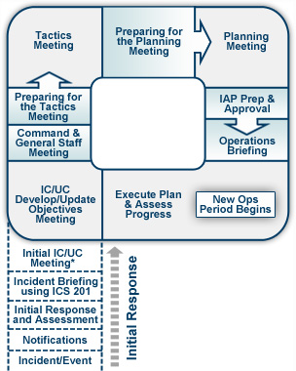
Incident Action Planning starts with identifying the strategy to contain or terminate the incident and stabilize conditions. The strategy is broad and defines what must be done. Once the strategy has been defined, tactics are selected. Tactics are the operations that need to be completed to accomplish the strategy. They are measurable in both time and performance. The IAP includes support actions that may be necessary to make the plan operable. IMT members work with their teams and confer with others to carry out the tactics. It is necessary to assess the plan's effectiveness throughout the course of the incident and modify as appropriate based on current conditions to improve the plan's effectiveness. Information must be gathered from the IMT throughout the operational period and analyzed at the end of an operational period to make the necessary plan modifications.
For short-term events, where only a few units are engaged actively in a simple incident, the IAP is developed in the mind of the IC. The IAP includes the strategy and tactics for the incident and the supporting operations that must occur. The IC must ensure that operating resources and managers know the overall strategy. This information is conveyed when orders are issued to arriving emergency responders and other IMT personnel. The IAP must be written down for events that tend to be larger in scope and complex incidents that last long. The plan is developed for the next operational period with input from attendees and is placed in writing with an understanding of the goals and objectives to be accomplished. Additional planning meetings are scheduled on a frequency dictated by the needs of the incident. Modifications to the IAP are then made and distributed.
The IC will establish communications with the EOC in a timely manner and maintain communications to share the IAP and its modifications as the incident and emergency evolve and are managed, as well as to request resources.

After-Action Report (AAR)
After significant emergencies, usually requiring a Level 2 activation of the EOC or at the request of the Vice President of Administrative Affairs, the Department of Emergency Management will facilitate and coordinate an after-action review process. This involves the participation and input of appropriate stakeholders to describe the incident and identify strengths, weaknesses, and gaps regarding emergency management. As a result, an improvement plan is developed to outline strategies for corrective actions and the responsible parties/units to implement such actions. The objective is to improve operational readiness and resilience, including policy changes, plans, and procedures, training or retraining staff, procurement of commodities or contractual services, establishing mutual aid and other agreements, etc. These improvements to the achievement target capabilities will be incorporated and tested in mitigating strategies such as exercises.

Finance

Procurement
In an emergency declared by the University President or designee, FAU’s Regulation 6.008 3(b) 1. Emergency Purchases, supplemental to the Florida Board of Governors Purchasing Regulation 18.001(3) regarding competitive solicitations, give the President or designee the authority to waive the competitive solicitation process for the procurement of goods or services if it is determined a delay in procurement cause an immediate danger to the public health, safety or the welfare of person(s), animal(s), the preservation or protection of property, or the continuance of a vital University function. With this written waiver, the Procurement Department and Procurement support function is permitted to proceed with procuring commodities or contractual services without a competitive solicitation. The emergency purchase shall be limited to the purchase of the type of items and quantities needed or for a period sufficient to meet the immediate threat and shall not be used to meet long-term requirements.

Cost Recovery
The Emergency Support Function - Claims Management & Assistance manages the claims assistance and reimbursement process with the help of all emergency support functions and units.
The two main avenues of assistance are:
- Federal Disaster Assistance: Robert T. Stafford Disaster Relief and Emergency Assistance Act constitutes the statutory authority for most disaster response and recovery activities involving the federal government. To activate federal resources and assistance, the governor of the State of Florida must first respond to the emergency event and execute the state’s emergency response plan before requesting a presidential declaration under the Stafford Act. The governor must certify in writing that the event's magnitude exceeds the state’s capability to respond, and that supplemental federal assistance is necessary. Without a specific request, the president may provide accelerated federal assistance where it is necessary to save lives or prevent severe damage.
- State Risk Management Trust Fund: Florida Statute Chapter 284, Part I, requires the Division of Risk Management to self-insure all state-owned buildings and contents through the State Risk Management Trust Fund (the “Fund”). All State of Florida agencies, including FAU, insure their buildings and contents through the Fund. The Fund assesses state agencies at an annual premium, provides coverage for reported locations, and pays claims for property losses due to covered perils. Covered perils for which coverage is provided include fire, lightning, explosion, windstorm, hail, smoke, aircraft or vehicles, riot or civil commotion, sinkhole collapse, and flood.
Costs incurred from an event that prompts a state of emergency declaration by the Governor and a disaster declaration by the President of the United States of America may be eligible for reimbursement. Proper record-keeping and documentation of expenses are critical for reimbursement purposes.

Logistics and Resource Management
All university units coordinate, allocate, and manage resources necessary to contain, stabilize, and terminate emergencies. These include essential or emergency personnel, subject matter experts, equipment, supplies, and facilities.
To effectively manage resources in an emergency and post-disaster environment, the following actions must occur:
- Identify resource requirements.
- Order and acquire resources.
- Mobilize resources.
- Track and report resource status.
- Recover resources.
- Document.
- Complete reimbursement requests.
The Emergency Coordination Group of emergency support functions will, for an emergency that affects any campus (when there is an on-scene component) and, when deemed necessary for no-scene emergencies, determine the level of support and resources needed to contain, stabilize, and terminate the emergency.
The Resource Procurement Group of emergency support functions will work with all other applicable emergency support functions and units to procure resources. These resources and assistance can come in many forms, such as current inventories at the campus affected or from other partner campuses, the private sector, mutual aid, local, county, or state assistance, donations of goods or services, and volunteers.
The University participates in mutual aid agreements with local response agencies, and all SUS (State University System) institutions have entered into a mutual aid agreement for counseling services and resources.
Should the University exhaust its ability to manage an emergency, requests for assistance effectively can be made to the respective county’s EOC. During significant emergencies where the SEOC increased its activation level, the University can request assistance through the Board of Governors’ representative on the SERT. Additionally, the University is a signatory to the Statewide Mutual Aid Agreement (SMAA), which allows for written or oral requests for assistance during a significant emergency or disaster.

Education, Training, and Exercises

Training and Education
The Department of Emergency Management conducts individual, unit, and campus/University preparedness, planning and safety training throughout the year. Training programs are designed to address the unique needs of the area or requestor and the potential hazards or threats that may be faced.
Several university-wide departments offer safety and security training to the university community, such as FAU’s Police Department, Office of Information Technology, Division of Research, Human Resources, and Environmental Health and Safety. These training programs are designed to meet the target audience's unique needs and operations.
The Homeland Security Exercise and Evaluation Program (HSEEP) provides a set of guiding principles for the FAU exercise program and establishes a commonality to FAU’s approach to exercise program management, design and development, conduct, evaluation, and improvement planning.
Those FAU members who serve as the lead individuals for designing exercises should take, at a minimum, FEMA’s introductory exercise design courses online (IS-120.C). It is highly recommended that lead individuals also take the Homeland and Security Exercise and Evaluation Program (HSEEP) course (L-0146). Additional exercise design courses offered virtually include FEMA-E 132. FEMA E- 133 and FEMA E- 136).

Exercises
The University is committed to maintaining an exercise program given that the more a plan is practiced, and stakeholders are trained on it, the more effectively they can act before, during, and after an emergency to lessen the impact on life and property. Exercises provide opportunities to practice with community partners, including first responders and local emergency management, and to identify gaps and weaknesses in the plan and policy.
The Department of Emergency Management participates in and hosts exercises throughout the year. Hosted exercises utilize the Department of Homeland Security’s National Planning Scenarios, which serves as the basis for defining the tasks and capabilities needed to perform those tasks that may be required to successfully prepare for prevent, protect against, respond to, and recover from a wide range of threats and hazards. These exercises range from unit to university level and involve internal and external stakeholders as appropriate. An after-action review is conducted to identify areas of improvement or gaps in capabilities that must be addressed.
Several departments University-wide conduct or participate in unit or external exercises. These exercises measure their performance against target capabilities, identify areas of improvement or gaps, and implement corrective action plans to remedy these deficiencies.
FAU’s exercise program has been developed with long-range goals. The program is intended to become progressively more challenging, with more complex scenarios and exercises. This is succinct with the development and refinement of core capabilities.

Plan Development and Maintenance
The Department of Emergency Management facilitated the plan's development with participation from the Emergency Management Team. The Plan was written to be consistent with the State of Florida Comprehensive Emergency Management Plan and respective counties’ comprehensive emergency management or emergency operations plans. Federal guidance and standards were also utilized in developing the Plan to facilitate interagency coordination.
Revisions to this Plan will be on an “as needed” basis following actual events, exercises, revisions, or additions to governing laws or regulations or periodic review of Plan sections by the Emergency Management Team. The Plan will undergo formal review by the Department of Emergency Management with consultation from the Emergency Management Advisory Group (EMAG) every five years.

Authorities and References
Florida Atlantic University’s policy – University Policy 1.14 (Emergency Management) establishes the authority for the development and implementation of this plan.
The following laws, standards and regulations were used to provide the requirements, further authority, and guidance to develop this plan and its format:

Authorities

University
- University Policy 1.14 (Emergency Management)
- Essential Personnel Policy (Human Resources Department)

Local
- Palm Beach County Comprehensive Emergency Management Plan (CEMP)
- Broward County Comprehensive Emergency Management Plan (CEMP)
- St. Lucie County Emergency Operations Plan

State
- Florida Statutes (F.S.):
  - Chapter 23, Florida Mutual Aid Act
  - Chapter 252, Emergency Management
  - Chapter 768, Good Samaritan Act
  - Chapter 553.80, Building Construction Standards
  - Chapter 119, Public Records
- Florida Administrative Code (F.A.C.):
  - 27P, Division of Emergency Management
  - State University System of Florida, Board of Governors’ Regulation 3.001, Campus Emergency Management

Federal
- Public Law:
  - 100-707, The Stafford Act
  - 101-542, Student Right-To-Know and Campus Security Act
  - Homeland Security Presidential Directive 5, National Incident Management System
  - Homeland Security Presidential Directive 8, National Preparedness
  - Americans with Disabilities Act (ADA) of 1990 as amended
  - Higher Education Opportunity Act (HEOA), 2008
  - National Flood Insurance Program
- Documents:
  - Federal Emergency Management Agency (FEMA) Comprehensive Preparedness Guide (CPG) 101, Version 2, Developing and Maintaining Emergency Operations Plans
  - National Planning Frameworks

References
- University Habitat Management Plan
- University Master Plan – Objective 1D, GOP 13 - Conservation
- Florida Comprehensive Emergency Management Plan (CEMP)
- Palm Beach County Comprehensive Emergency Management Plan (CEMP)
- Broward County Comprehensive Emergency Management Plan (CEMP)
- St. Lucie County Emergency Operations Plan
- Guide for Developing High-Quality Emergency Operations Plans for Institutions of Higher Education
- International Association of Campus Law Enforcement Administrators (IACLEA) – Campus Emergency Operation Planning Guide
- National Fire Protection Association (NFPA) 1600, Standard on Disaster/Emergency Management and Business Continuity Programs
- National Planning Frameworks
- U.S. Department of Homeland Security Target Capabilities List

Appendix 1 – Declaration, University SOE
DECLARATION – UNIVERSITY STATE OF EMERGENCY
WHEREAS, FLORIDA ATLANTIC UNIVERSITY emergency policies and procedures empower the President or authorized representative to declare a University State of Emergency, when the University has been affected by the emergency or disaster; and
WHEREAS, the President of Florida Atlantic University or his/her designee has determined:
That conditions of peril to the safety of persons and property and the environment have arisen caused by _____________________, commencing on or about _______________, on the date of ______________, warranting the necessity for, and declaration of, a University State of Emergency, until further notice.
NOW, THEREFORE, IT IS HEREBY DECLARED AND ORDERED that:
That a state of emergency is declared for ☐ All campuses and sites ☐ For the following campus(es) or site(s):_______________________________________________________________ and shall be deemed to continue to exist until its termination is declared by the President or authorized representative of Florida Atlantic University;
That the University’s emergency plans and appropriate campus(es)’ and/or site(s)’ plans have been implemented, in particular to include:
☐ Suspension of normal academic operations: __________________________________ ☐ Activation of emergency accounting and procurement procedures
☐ Implementing essential personnel protocols and procedures
☐ Suspension of other functions and operations: _________________________________
That any and all units with a role in emergency operations are hereby ordered to implement emergency procedures as applicable, or take whatever prudent actions are necessary to protect the health, safety, and welfare of the Florida Atlantic University community and prevent damage to University property and the environment;
That this proclamation shall take effect immediately from its issuance.
IT IS FURTHER ORDERED that a copy of this declaration be forwarded to the Florida State University System Board of Governors, and local and state entities, as appropriate.

______________________________ _______________
President or authorized representative Date

